LORETO GIRLS 2025 PREDICTION
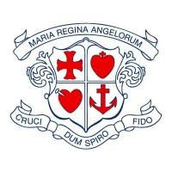

(EXPECTED KCSE EXAM)
Kenya Certificate of Secondary Education (K.C.S.E)
BIOLOGY
PRACTICAL
Paper 3
Confidential
The information contained in this paper is to enable the head of the school and the teacher in charge of Biology to make adequate preparations for the Biology practical examination.

Each Candidate will Require:-
- L1 – Sodium hydrogen carbonate solution supplied with a dropper.
- L2 – starch solution supplied with a dropper
- (Olive) oil supplied with a dropper.
- Benedict’s solution supplied with a dropper.
- Iodine solution supplied with a dropper
- 5 clean test tubes.
- Irish potato
- Scalpel
- Amylase solution
- 4 labels
- Motar and pestle
- Distilled water in a wash bottle
- A 30cm transparent ruler
- 10ml measuring cylinder
- Means of timing e.g. clock / stop watch.
- Means of heating.
- Hibiscus flower marked K

